Critical questions
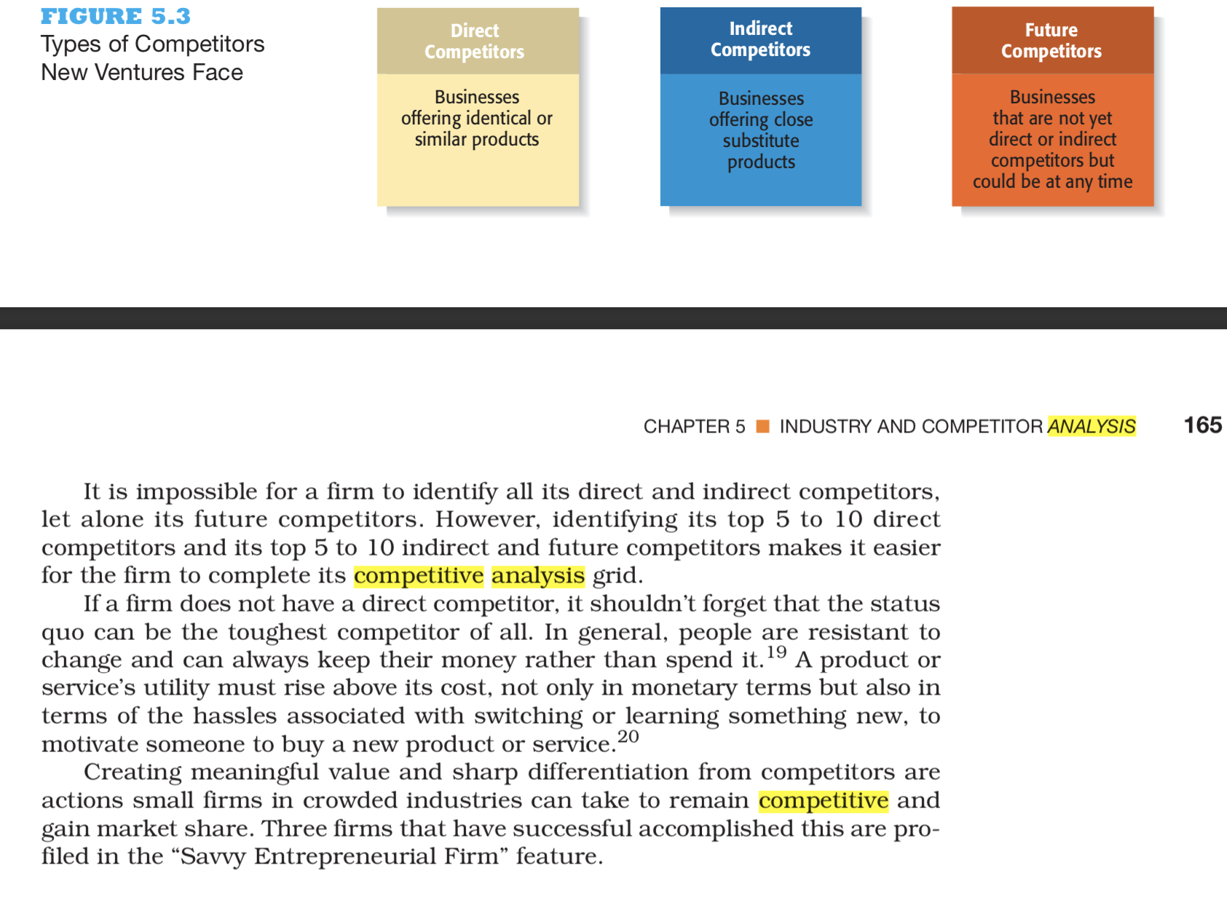
Competitors Report
Write a two page paper analyzing the competitors in your industry.
Analyzing Topic: Tracking Devices to protect children (Choose 3 competitors)
Look at the critical questions in the discussion section of the module and attempt to address some of them.
The chapter provides you with great coverage on how to write the competitor's analysis.




Example from the book
Completing a Competitive Analysis Grid
As we mentioned previously, a competitive analysis grid is a tool for organizing the information a firm collects about its competitors. It can help a firm see how it stacks up against its competitors, provide ideas for markets to pursue, and, perhaps most importantly, identify its primary sources of competitive advantage. To be a viable company, a new venture must have at least one clear competitive advantage over its major competitors. 
